# Project Documentation

Contributed in use cases 2,3,5,6, shell screen, navigations, models and providers.

1. Made the Shell screen and main screen enabling smooth navigation between the screens for all screen and detail screens.

1. Made DashBoard and hardcoded the details.

1. Made the customers screen to view the customers and allow for crud operations and search operation, and on tap on the tile it navigates to customer detail screen.

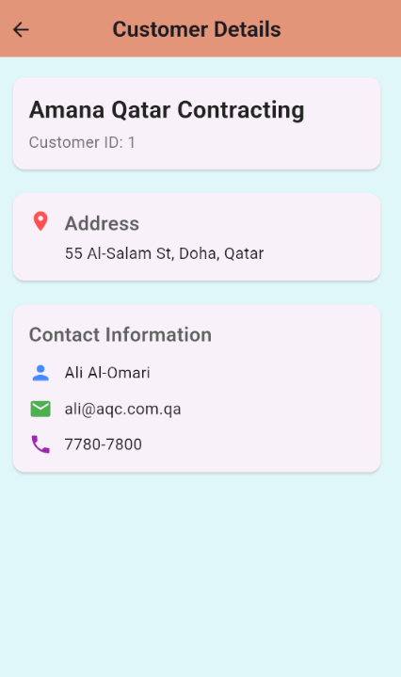

1. Made the Invoice payment screen and allowed for Crud operations and searching and if cheque is selected when adding or editing the cheque input will show. Made Payment Detail screen for viewing more information and if the mode is cheque it will show cheque Details and picture that you can view better by tapping on it.

*Note: The cheque image field for edit and add is a seletion of cheque image name of cheque images already present in assets.*

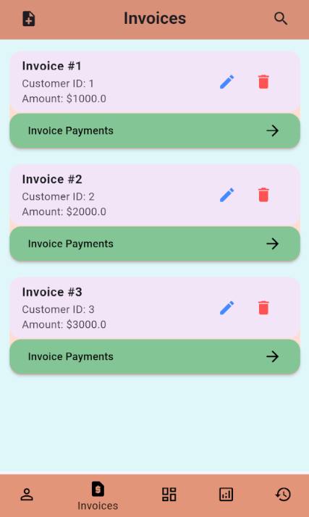 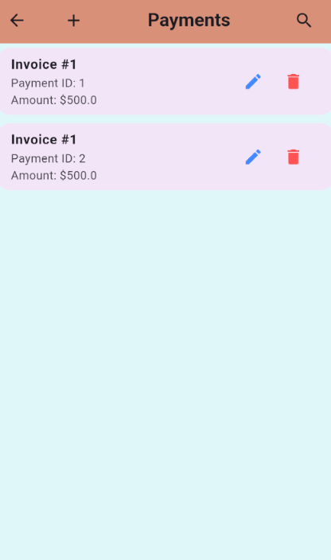

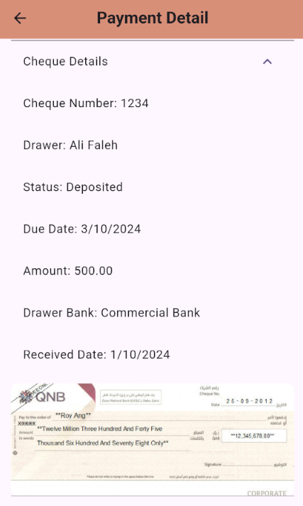

1. Cheque Deposit screen
   1. Views awaiting cheques in a tabular for using Data Table and allows scrolling vertically and horizontally. You can select one or multiple cheques to deposit and select the bank from drop down menu and submit (if no Cheque selected, then it does not allow depositing). And you can navigate to deposit history page to view deposited cheques using Deposit History button.

* 1. Deposit History views cheques Deposited, allows viewing of picture of the cheques by clicking the image names under the cheque image column and under the last column views the total of the deposited cheques.  
     You can select cheques you want to update(multiple cheques can be selected) and select either cashed or cashed with return ( cashed is default) and app will allow updating both. One of multiple can also be deleted.  
     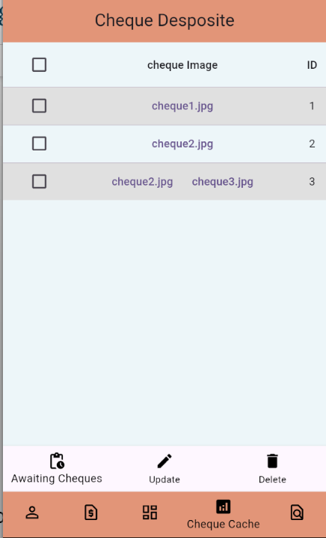A screenshot of a phone

     Description automatically generated
  2. In this case there are 3 cheques, 1 in deposit #2 and 2 in deposit #3. So on update it will show 2 Expansion Tiles, and 3 cheques will prompt for update, 1 under deposit #2 and 2 under deposit #3. If cashed with return is selected then it will also show return reason fields for all 3 cheques along with the return date field. Todays date is default pick. On submit it will change the status of the cheques and not view in deposit screen anymore.  
     